**Enable Test Manager in UiPath Automation Cloud Community Edition**

Activating UiPath Test Manager

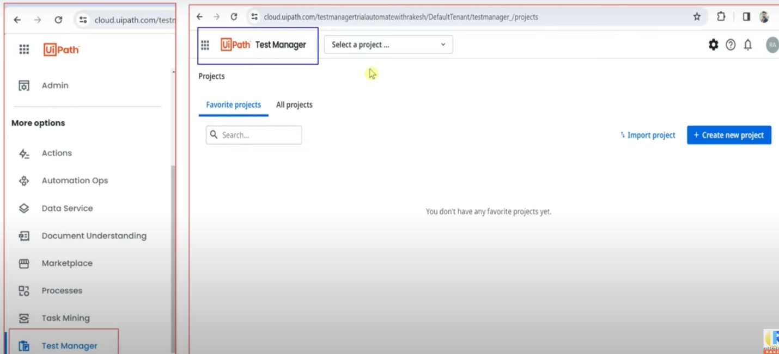

Browse "**Uipath Test Manager**" in google & click on the below site.

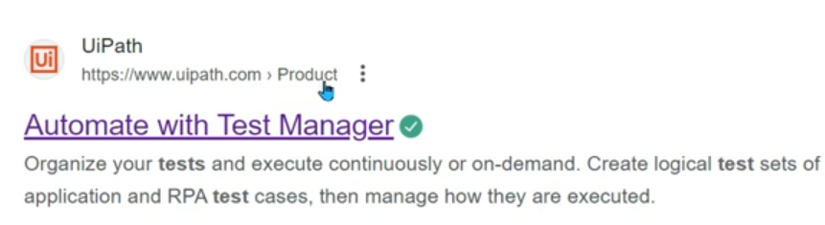

You will land to the below page, click on "Try for free" below.

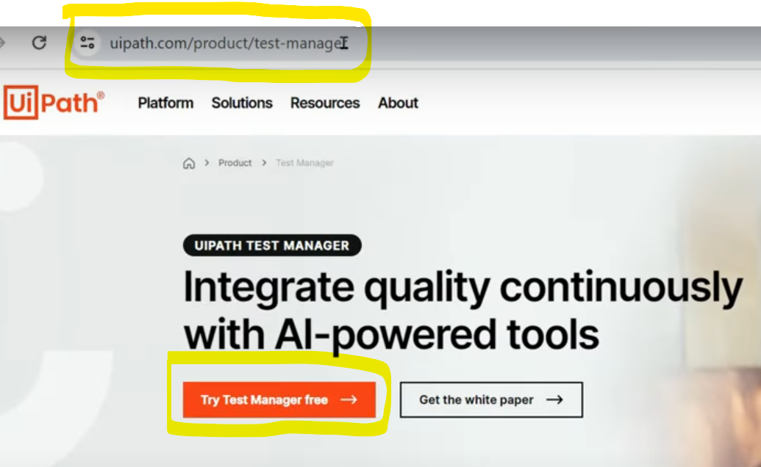

If you are already logged in to any tenant, recommendation is to logout.

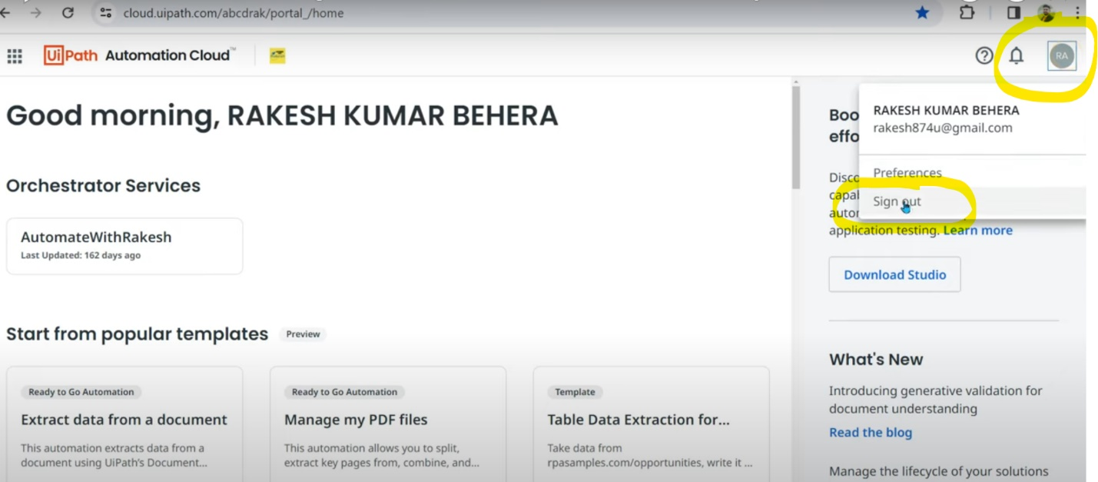

Now you will be able to see the already created tenants with your Gmail ID.

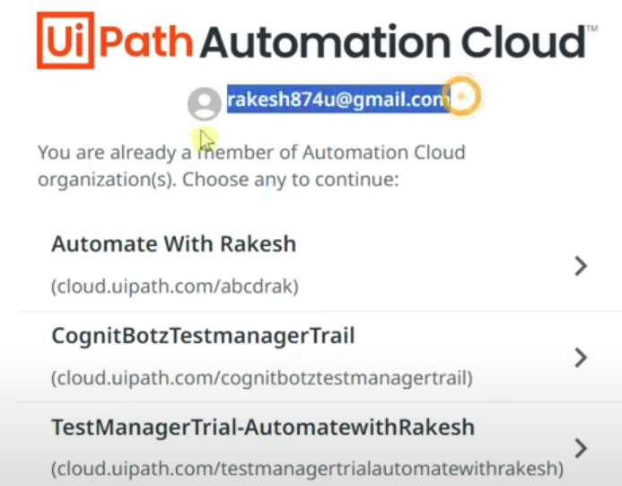

To try test manager newly, create a new organization like below. Else you can go ahead with existing tenants.

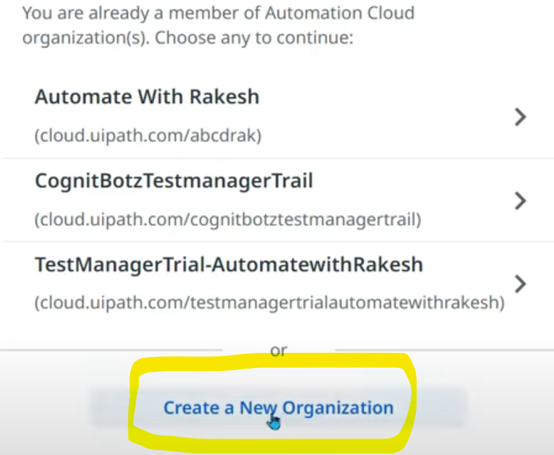

You will navigate to tgis page, continue with google to login. Choose account, give data & create tenant.

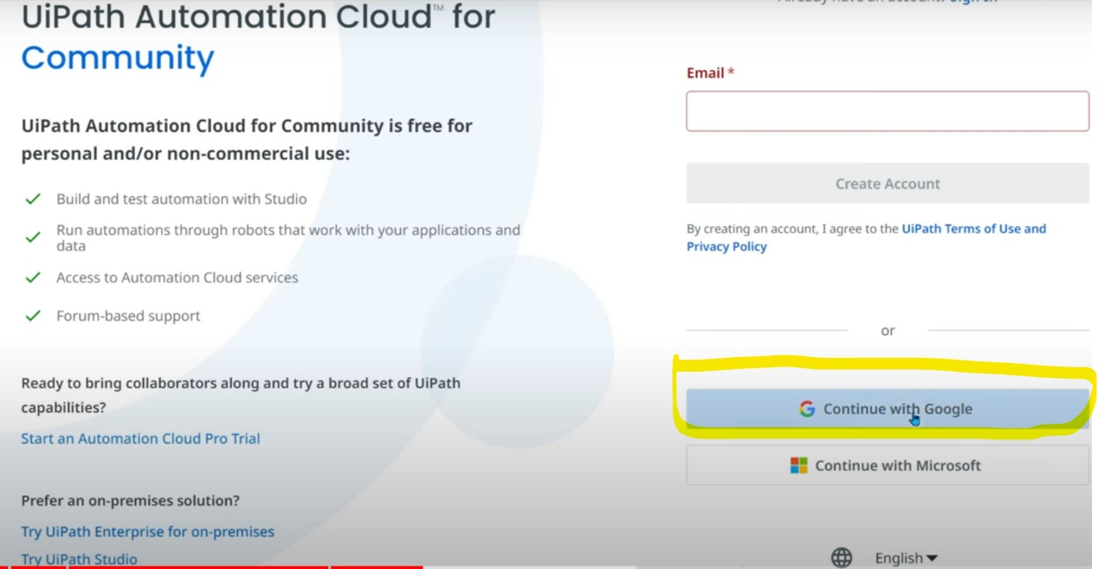

Enter the name & click on "Create Organization".

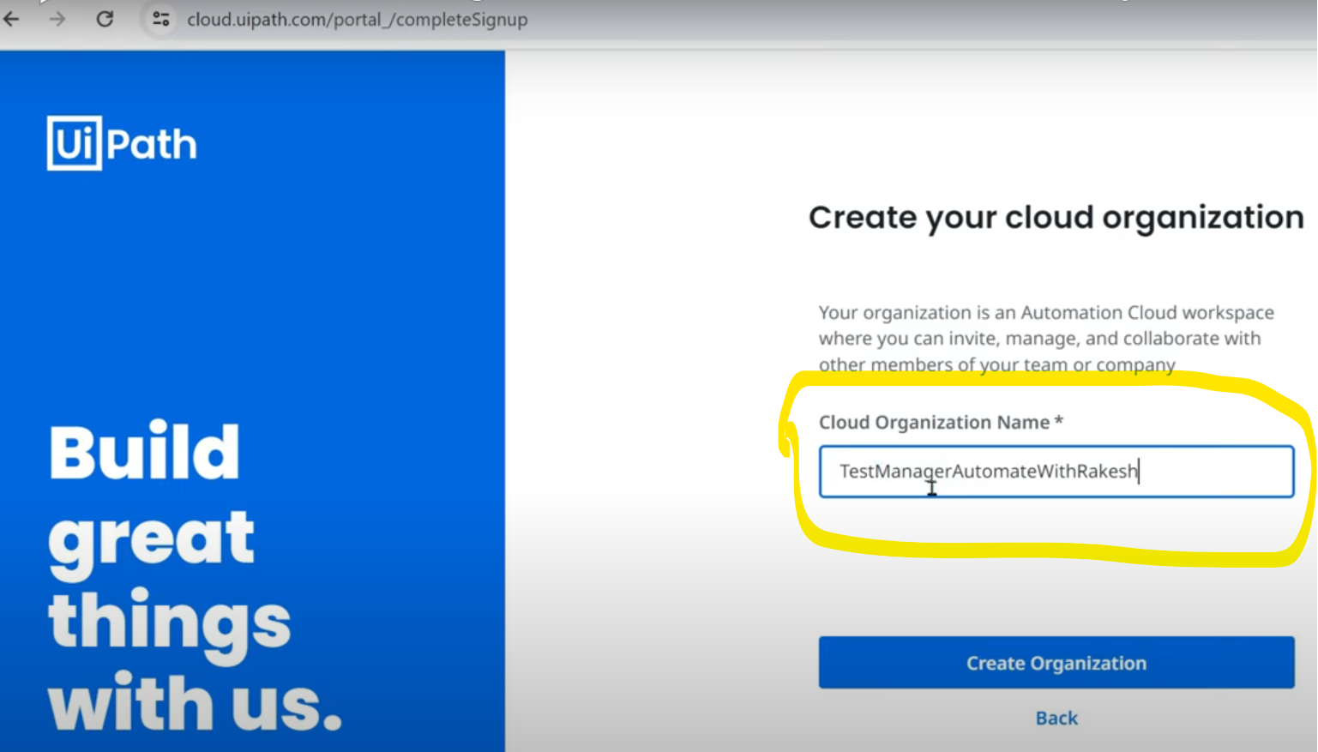

**After that login to cloud.upath.com**

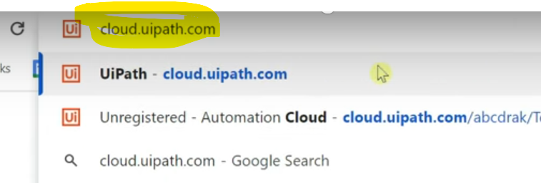

It shows all existing accounts & you can choose the one you just created above or the old ones.

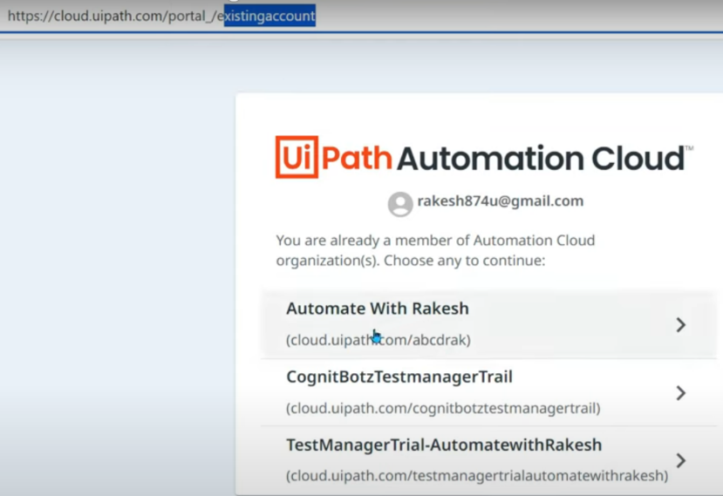

After checking for "UiPath Test manager" in the 3 dots below, you may not find & in that case, click on "Admin"

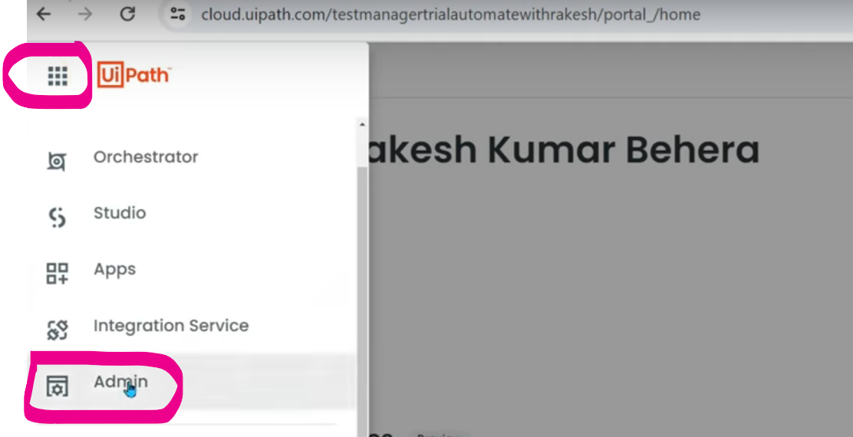

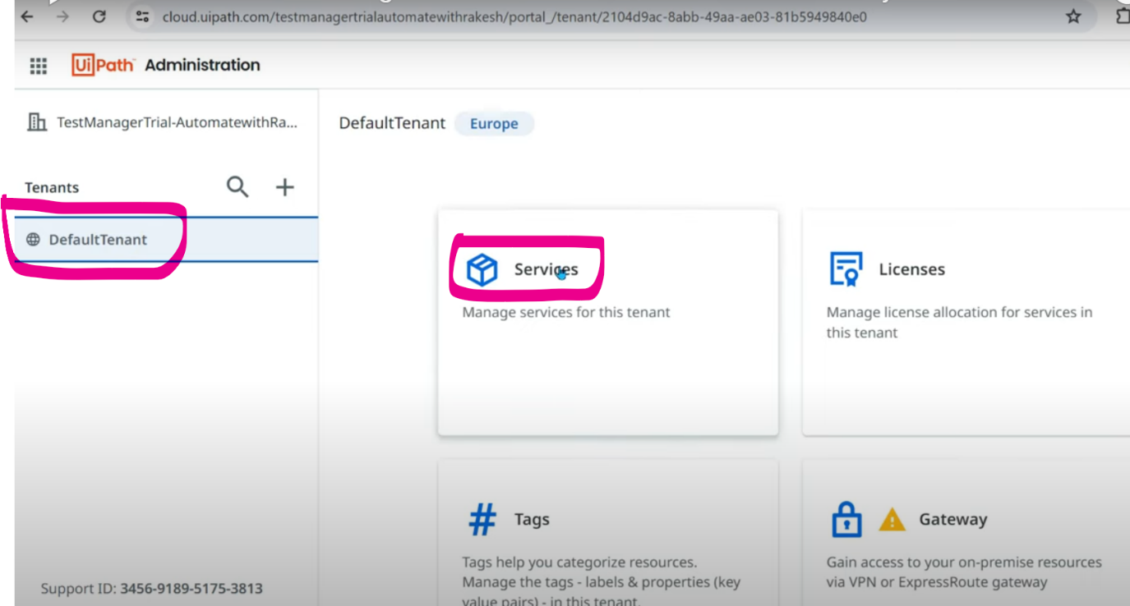

You will find an option to choose the services which you want to add & then you need to check "Test Manager" to add this service on your menu. Once it is done, you will find the service like this, click on 3 dots->Launch

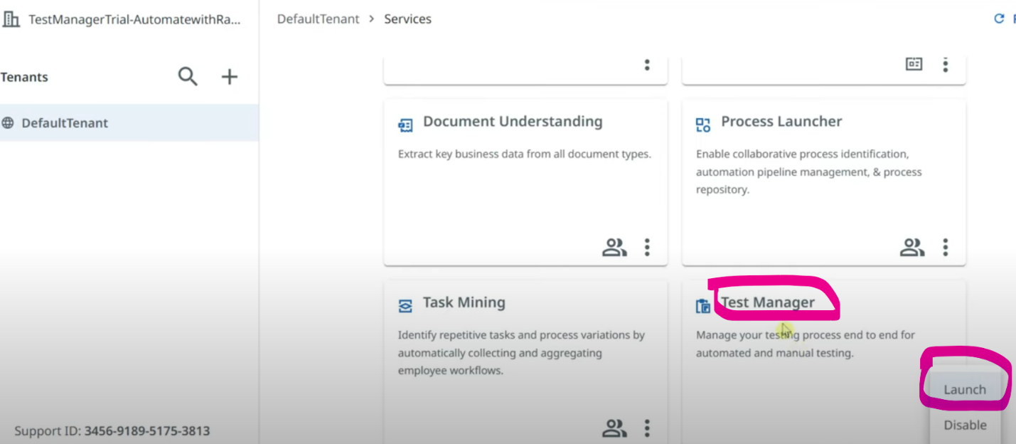

Now you can see you have logged in & activated your test manager.

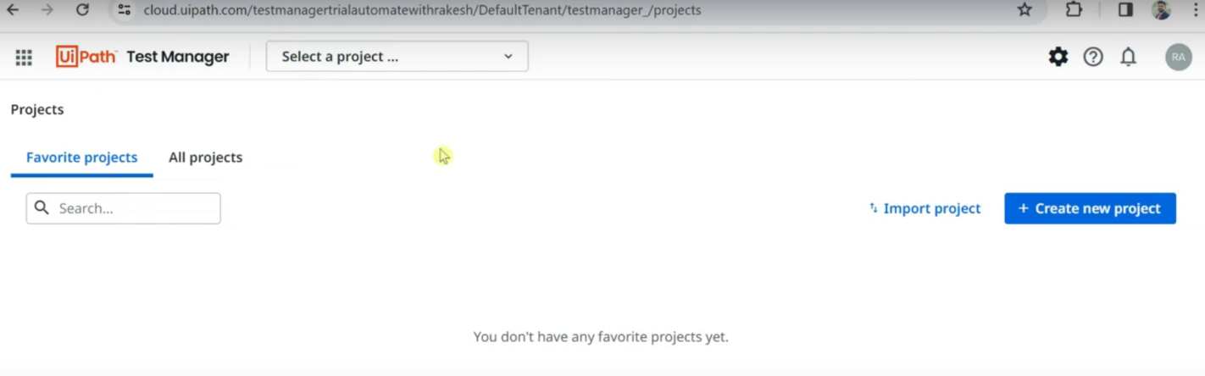

After enabling the service from Admin page, if you still don’t find "Test Manager" in the list, just refresh the page & in some time you will find it.

Test manager will be found in Design tab of uipath.

To integrate with studio, enter URL & connect, then we can create project & create test cases & test sets accordingly.

=================================================================================================================================

=================================================================================================================================

=================================================================================================================================

=================================================================================================================================

**Introduction to RPA Testing with UiPath Studio**

When you are building a software, you do some testing's as well.

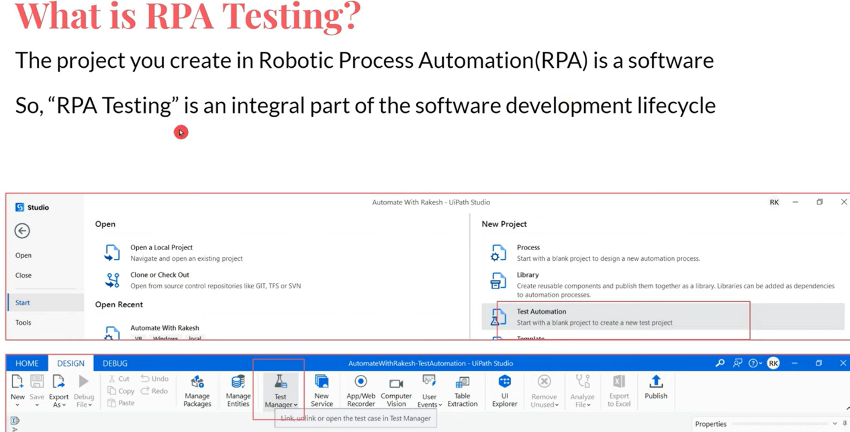

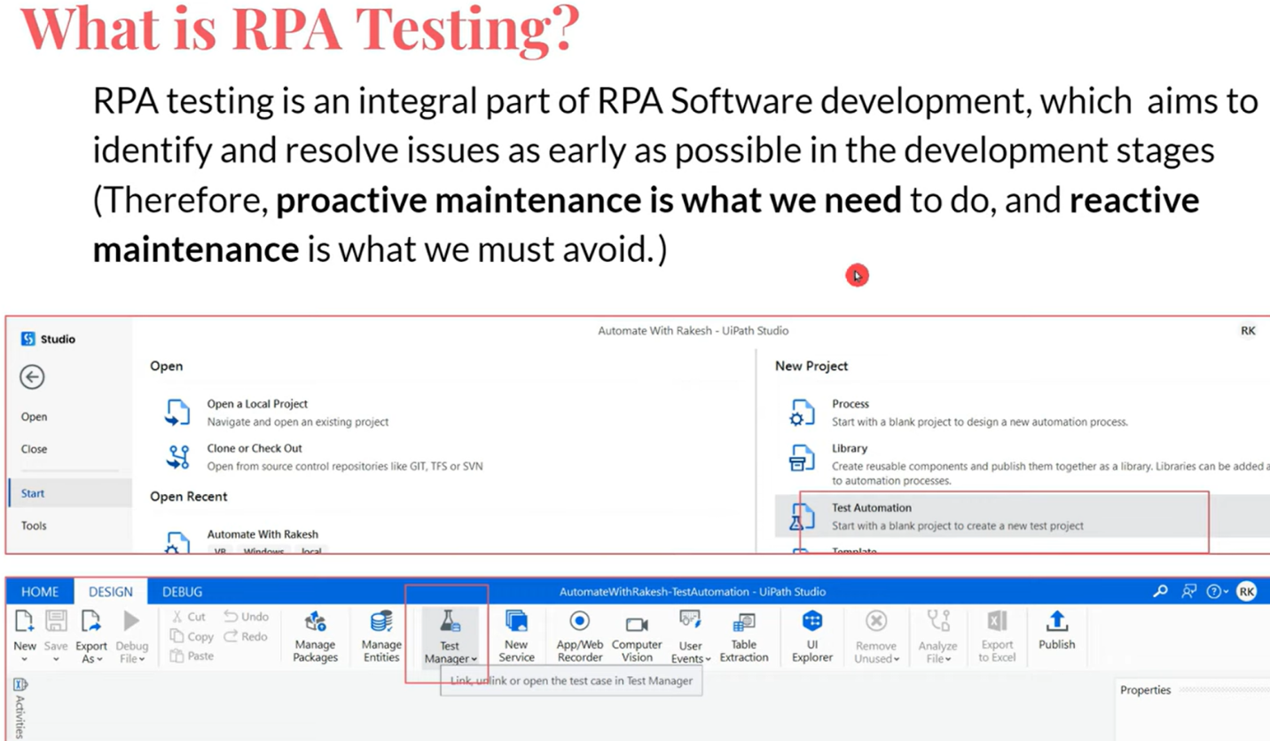

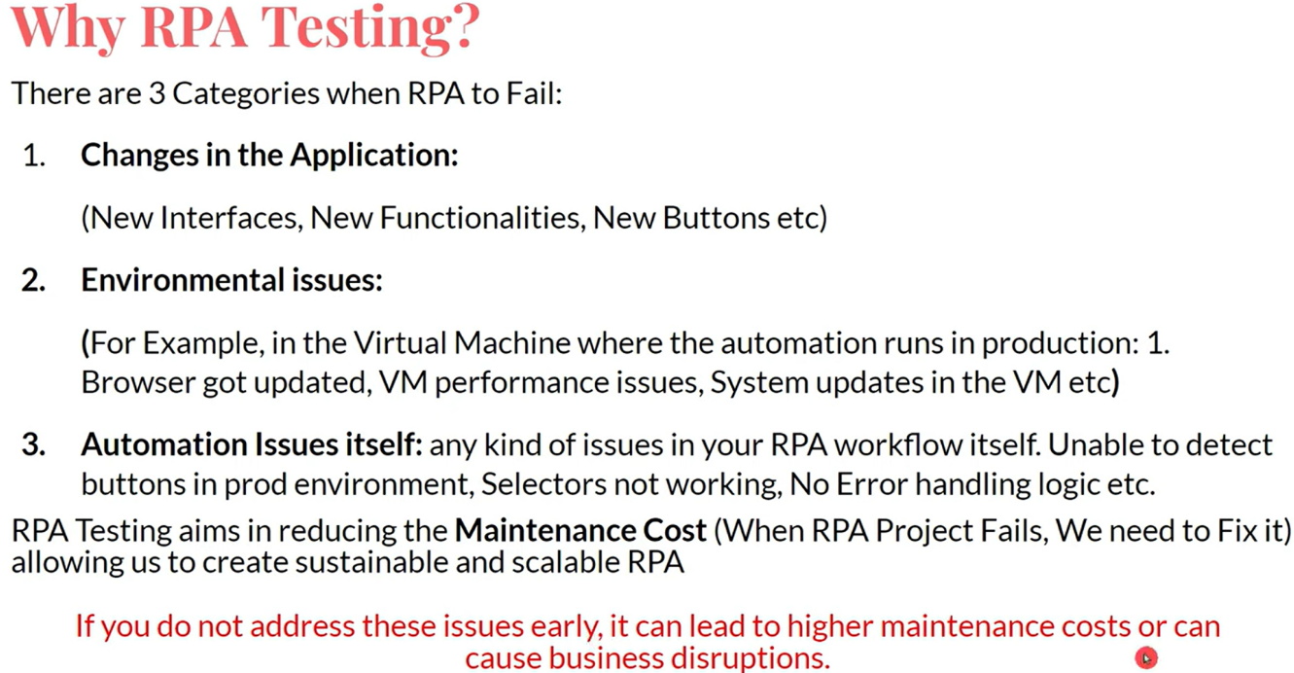

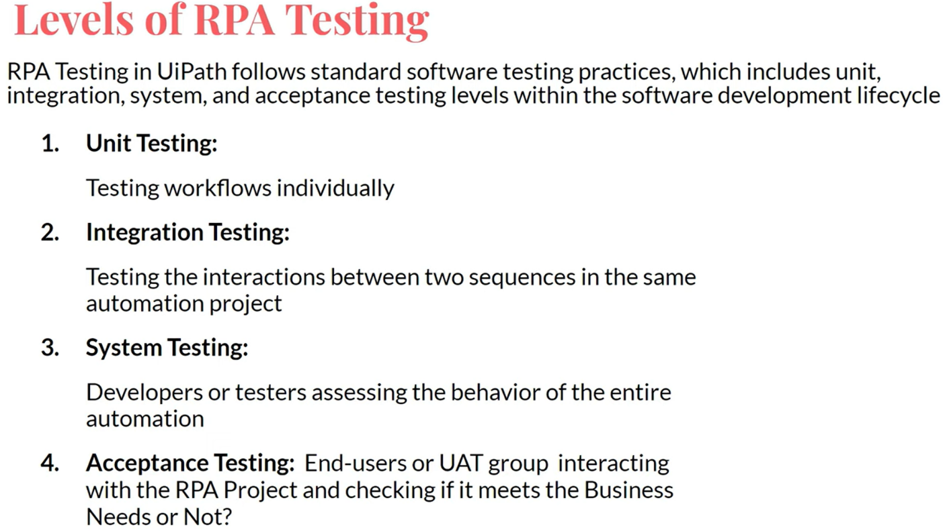

**Unit Testing:** Testing at xaml level, testing individual sequences and xamls.

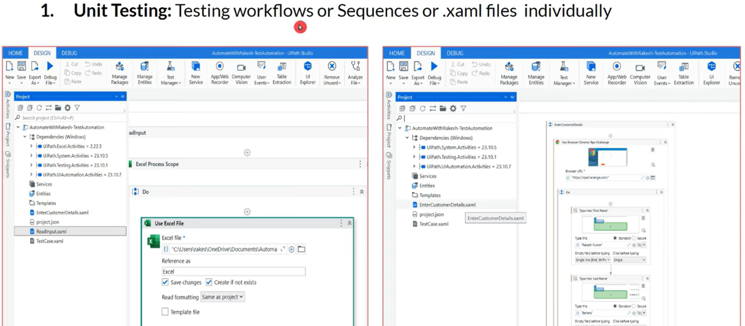

**Integration testing:** Let's say I'm reading excel & utilizing that in 2nd xaml to enter data into application. Data is divided into small parts & passed as arguments to 2nd xaml. Testing all these activities that happen between multiple different sequences is called Integration Testing.

Testing the code if it is working fine together after xamls & sequences are integrated.

Communication between 2 sequences or xamls are tested here.

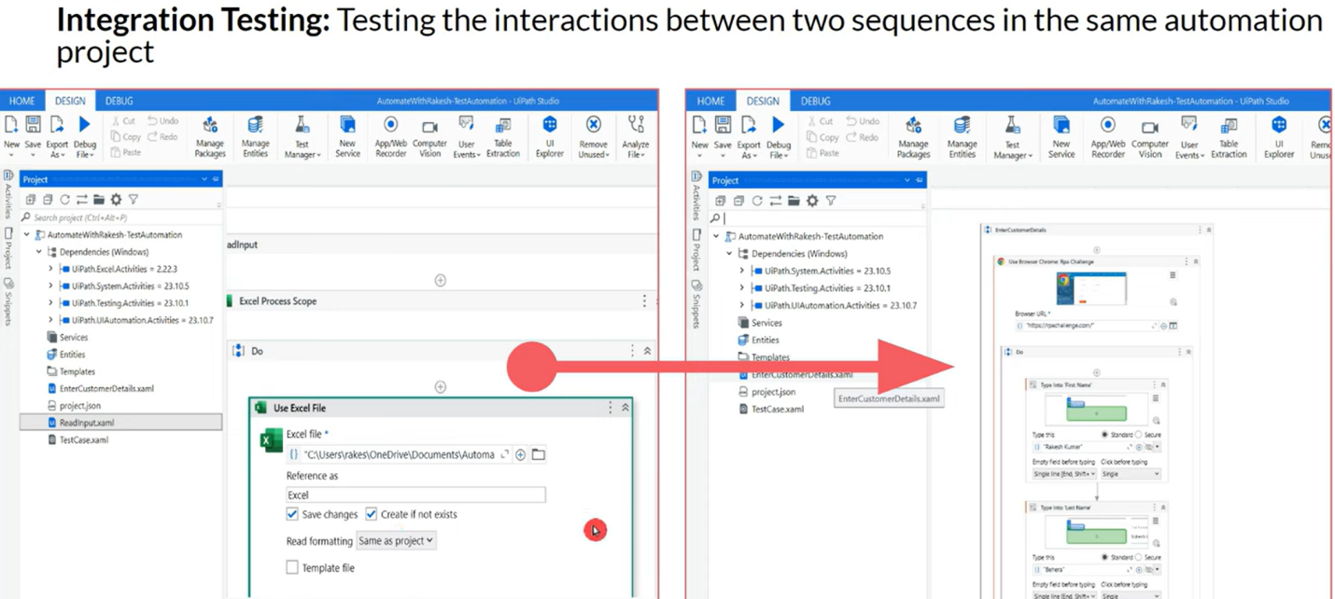

**System Testing:** We might have multiple xamls. When run overall, it is meeting expecting behavior, standards & business needs. Is it doing exactly the same way or any errors and is there error logic handled. The entire project testing is system testing.

Is it fulfilling business needs is tested here.

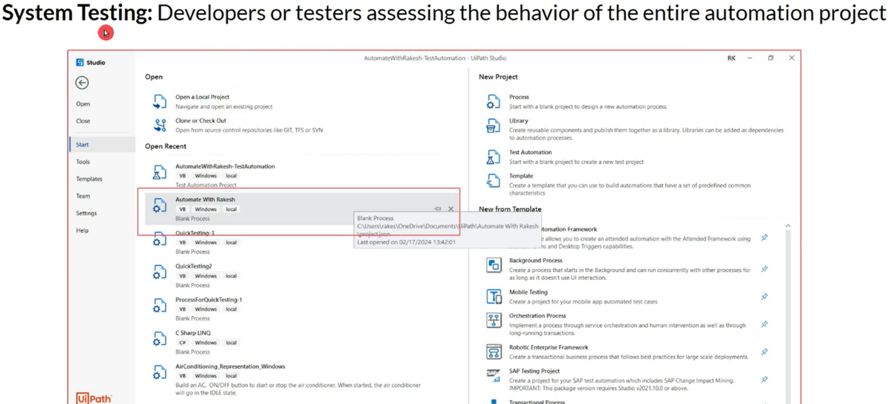

**User Acceptance Testing:** From client part, someone will be testing to check if it is meeting expected behavior & expected logic. If there is any logic change or something needs to be added, that will be done here. Basically User has to accept the automation run results in this testing by checking the automation results & verifying with their expected needs.

When end user accepts, the code goes to Production.

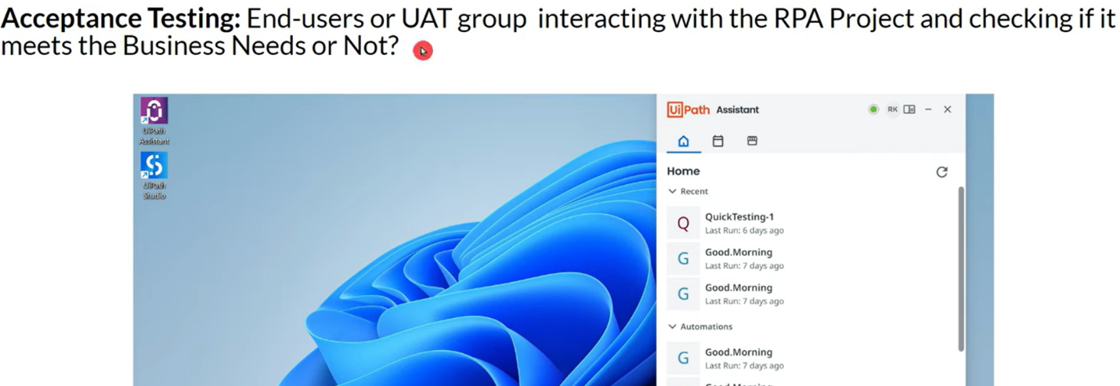

**Test Explorer**

<https://docs.uipath.com/studio/standalone/2024.10/user-guide/test-explorer>

NOTE:

1. If you have a data-driven test case, it shows up collapsed by default, with the number of variations placed under parentheses (e.g., TestCaseValues (6)).
2. Test Explorer results information is session-based. This means that if you close Studio the information shown in Test Explorer will be cleared.

Test Explorer is a panel that shows information relevant to test automation. You can use Test Explorer and its sub-panels to group tests together, perform debugging, or analyze activity coverage.

These details below will be reflecting in "Test Explorer" from "Project" tab.

This project has 5 xamls including "Main" & all the test cases associated with these xamls are also reflecting here.

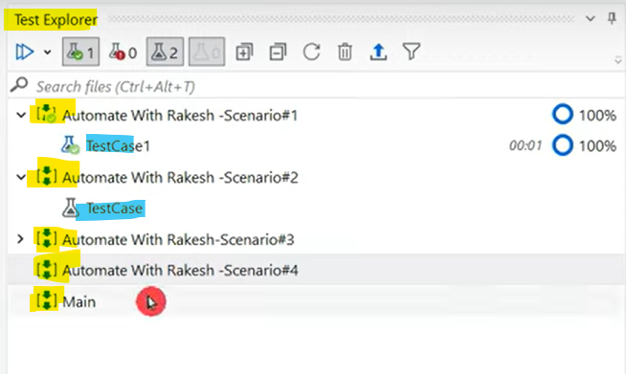

There are different templates to create project.

**Process template:** When created project using this template, we can see both xamls & test cases

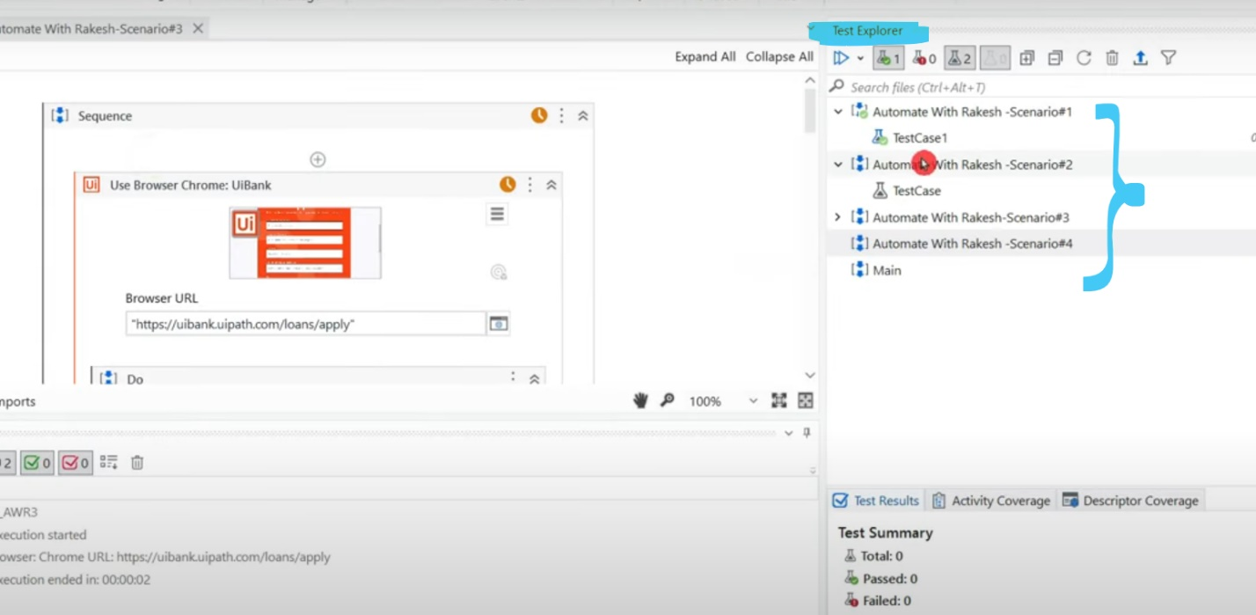

Test Automation template: When created project using this template, we can see ONLY test cases by default but using filter options we can get workflows too.

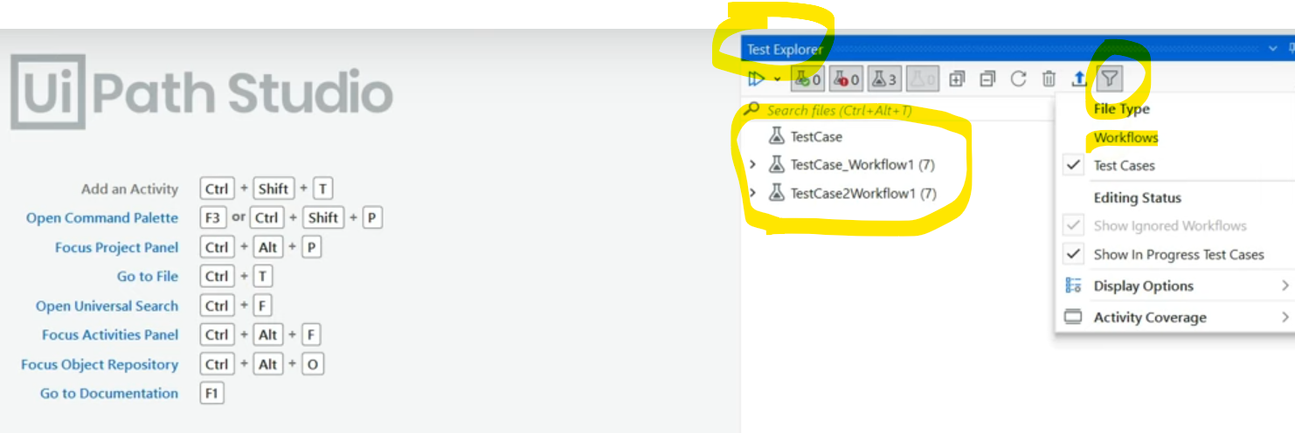

FILTERS in test explorer:

If you uncheck all 3 then it will be empty

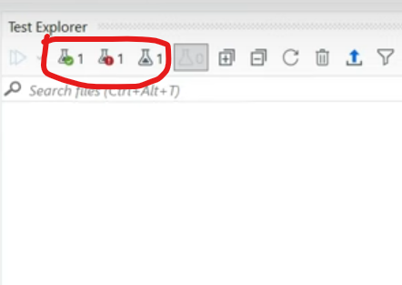

But if you keep it checked, you will find the details like below.

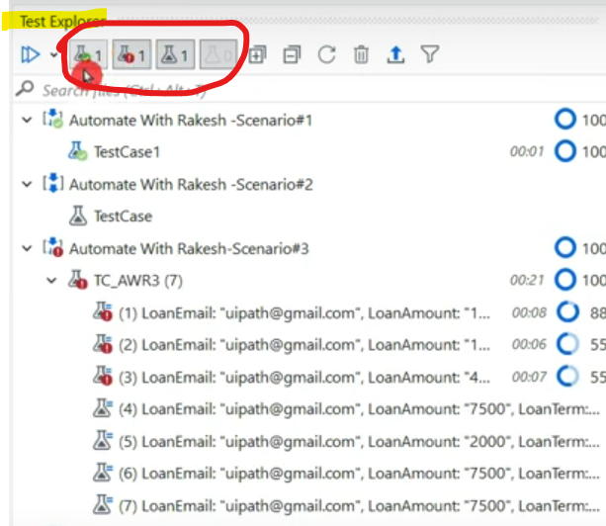

1. Green Filter - Passed test cases: It is the very 1st one which shows passed test cases.

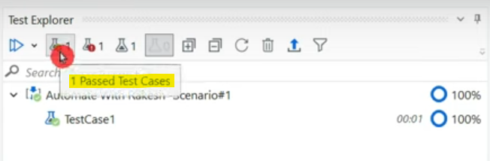

1. Red filter - Failed test cases: This is the 2nd one.

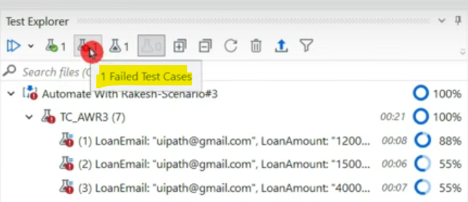

1. Blank - Not evaluated test case: Test cases which are not executed yet.

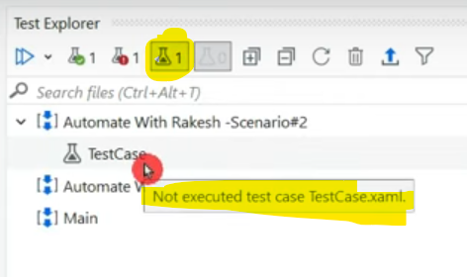

1. If you select all above 3 filters & click on 1st button, it shows below options.

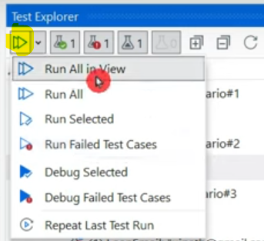

* Run All in view: Runs all that are in the view after FILTER is applied. If all filters are applied, all are run. If 1 filter is applied, only that is run.
* Run All: Filter doesn't matter. It runs everything available in the project.
* Run selected: Run only selected cases & workflows, also you can right click and run.
* Run failed test cases: Re-run only failed cases.
* Debug selected:
* Debug failed cases:
* Repeat last test run:

**Creating Your First Test Case**

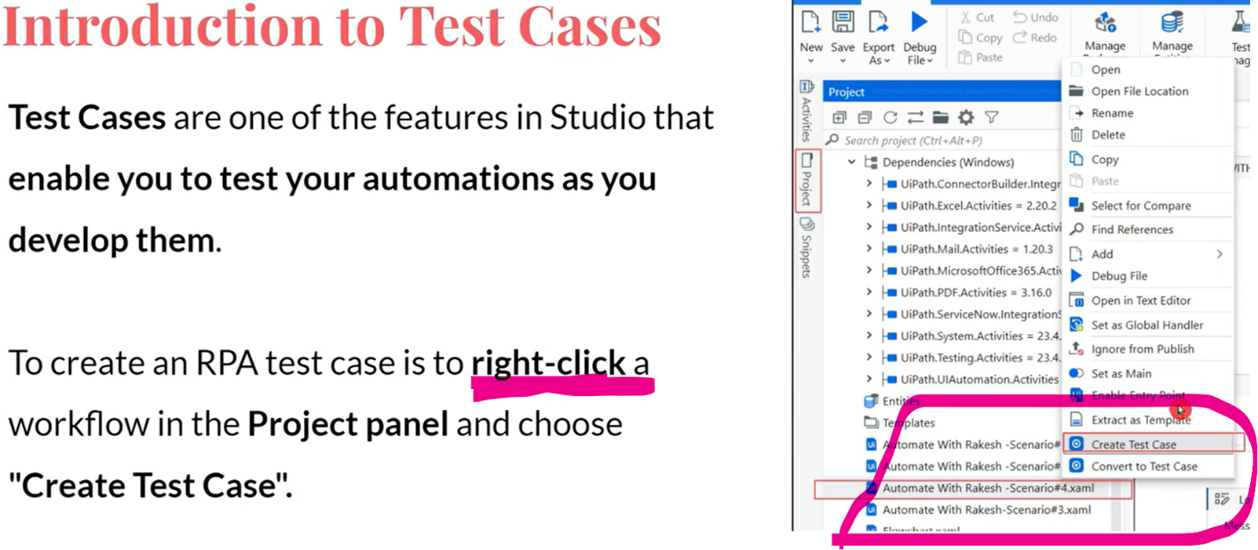

The below window appears when you try to create test case. Let's understand what is BDD test case

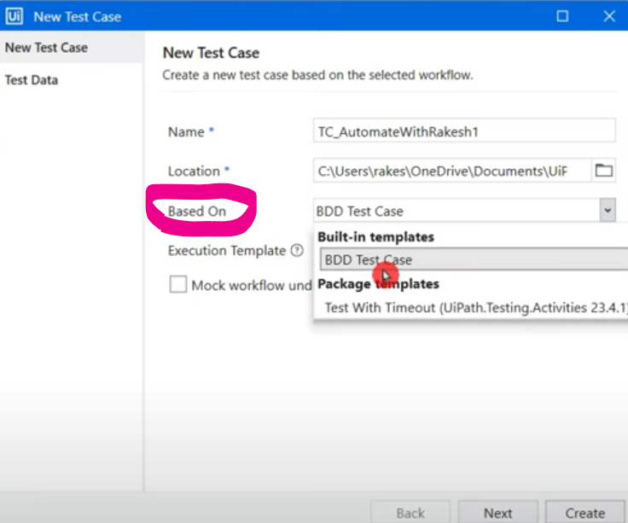

Here we will check the behavior of button below. If "checkout" button is there then fine, if not, what it should do. These behaviors will be tested.

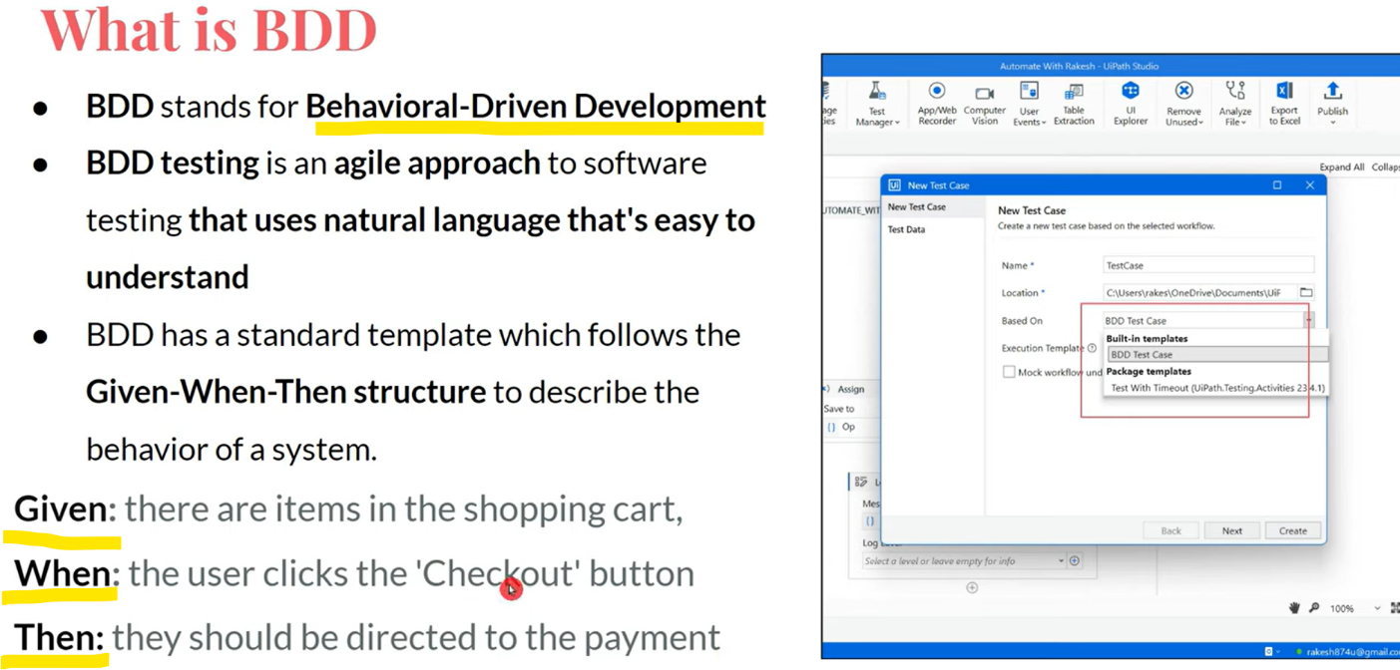

Select BDD test case & create.

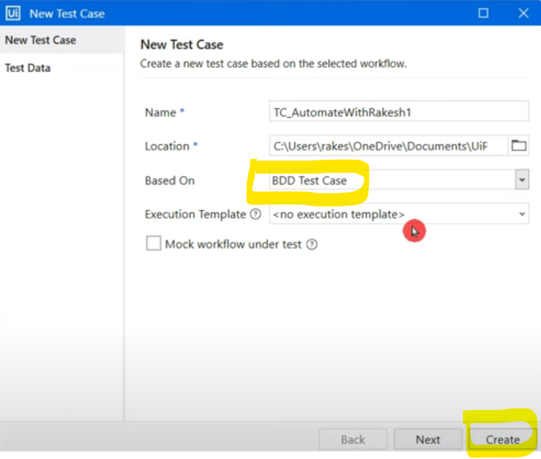

3 sections get created when you create a test case with **BDD which has a template - given, when, then as below.**

**Given: some input**

**When: the xaml is run**

**Then: required output produced is validated**

To test what output should be produced when what input is given, this BDD template test case will help you.

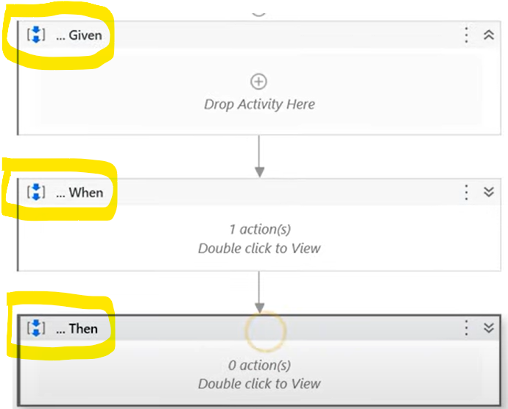

Inside the "When" section we will find the xaml on which we right clicked & created test case

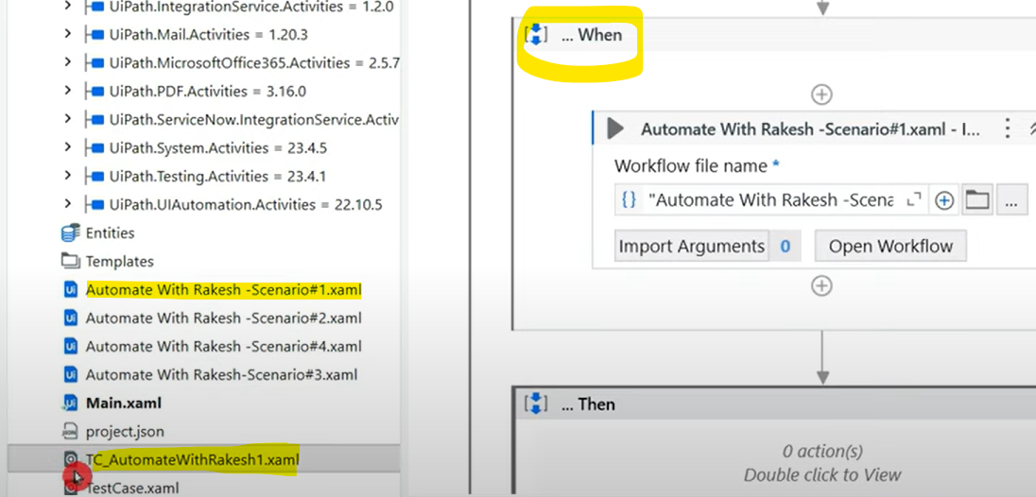

**NOTE: test cases are also xamls but grey in color unlike xamls while are blue in color.**

Let's test the below example.

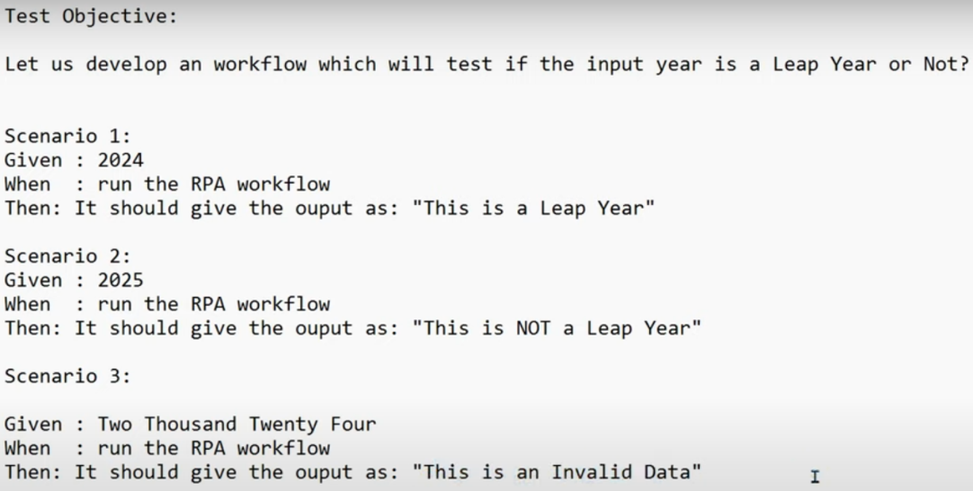

Let's build a xaml to test if year is leap year or not. Create Input & Output ARGUMENTS as these will be passed between 3 sections.

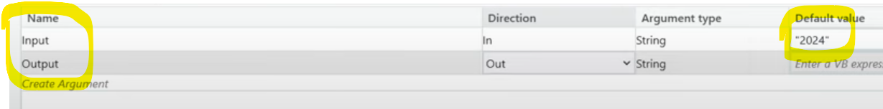

Create an integer type variable & convert the input value to Int & store in it.

Suppose, you pass string value like "Two Hundred", this produces casting error in "Assign" activity while converting string to Int. So surround the whole code with Try Catch

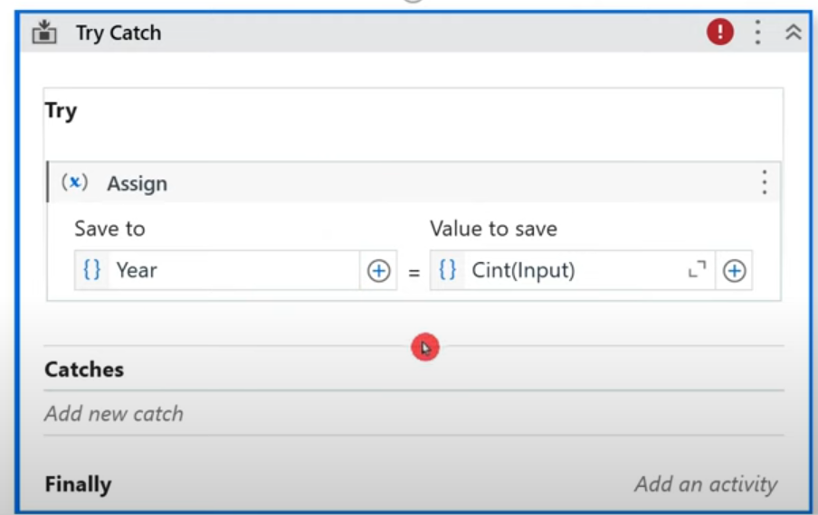

Set the exception type to Invalid Cast like below.

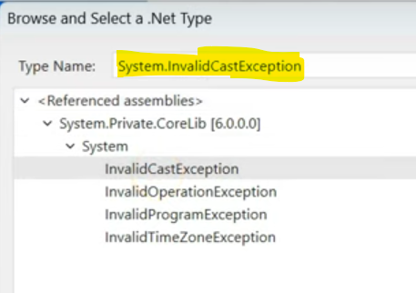

Log a message with required information.

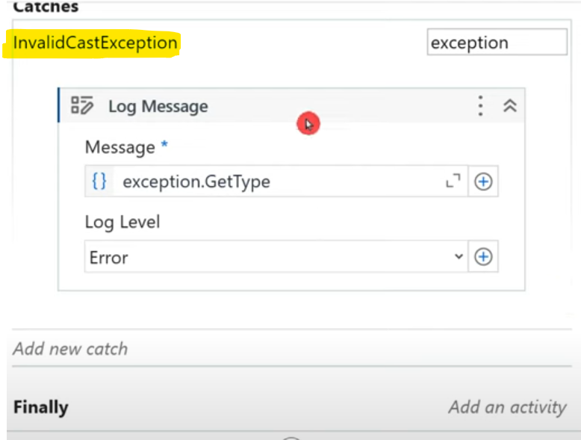

So in exception scenarios, output will be in catch section like below.

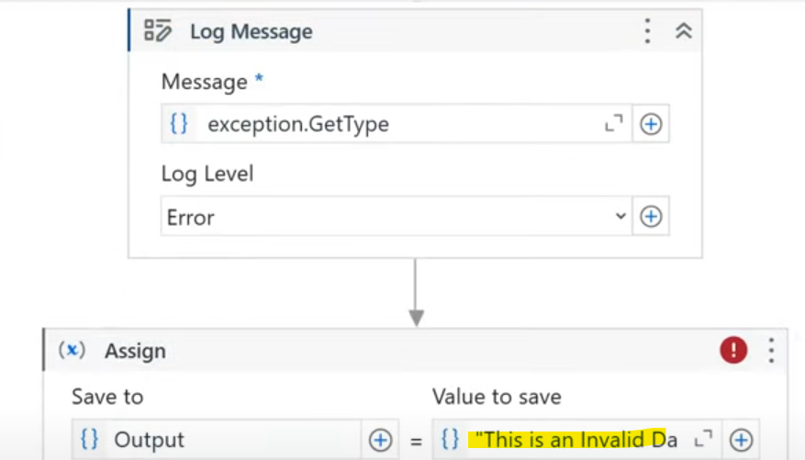

Add IF activity & update like below.

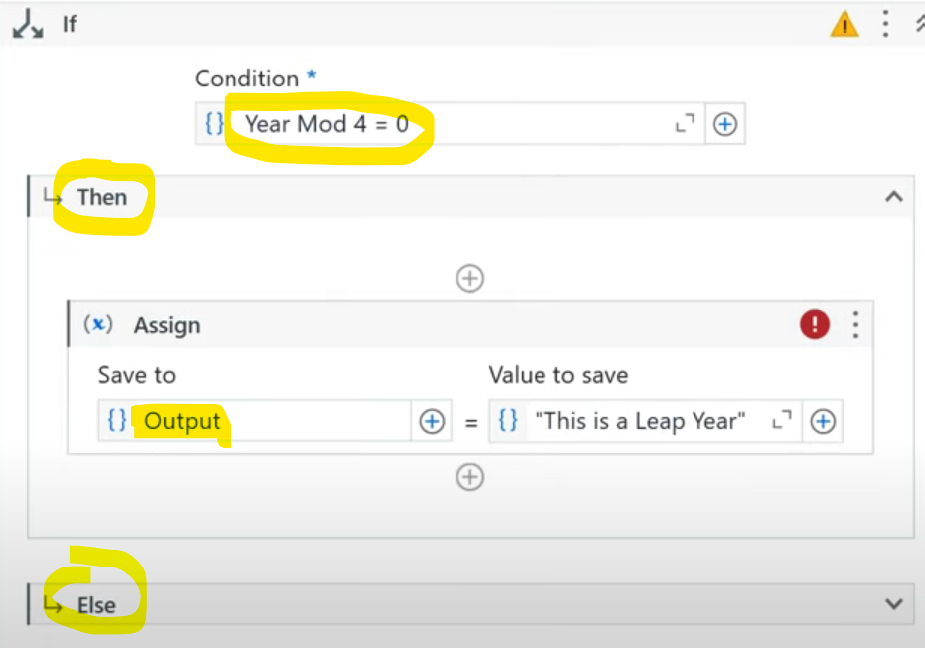

In the test case, GIVEN section-> assign an input variable

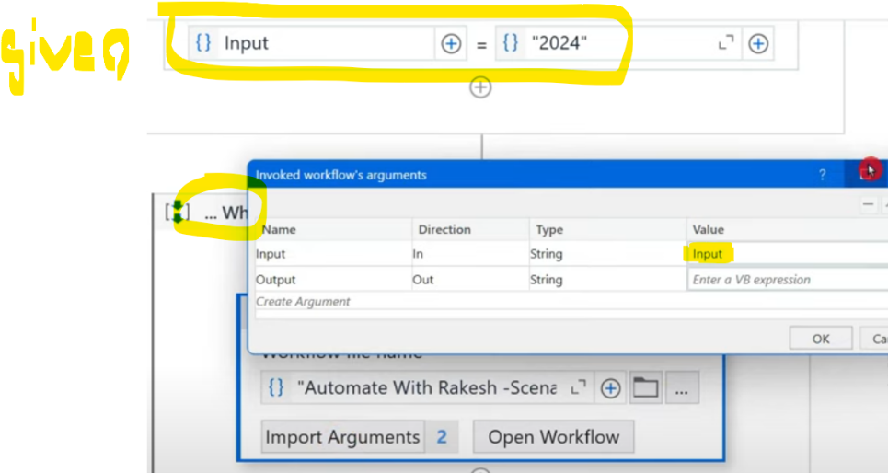

Pass the same inside the argument section of WHEN. For output you can create another variable to take out values from WHEN.

Inside THEN section, place a switch activity like below.

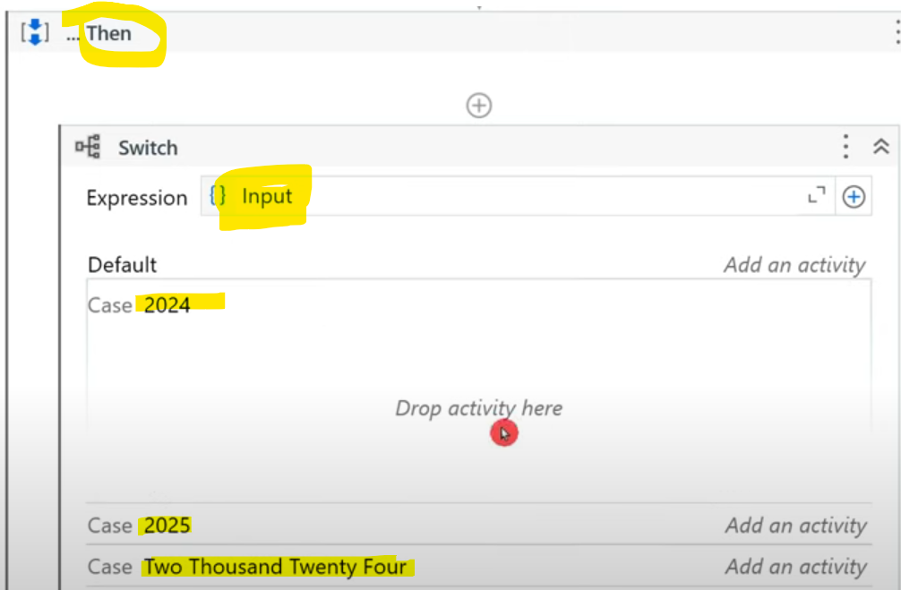

There are many activities to verify the testing results like below.

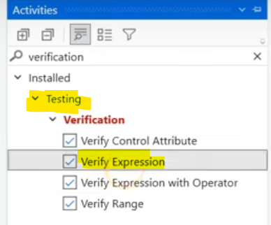

To verify, if our code is generating the required results, we use verification activity like below by providing the input conditions.

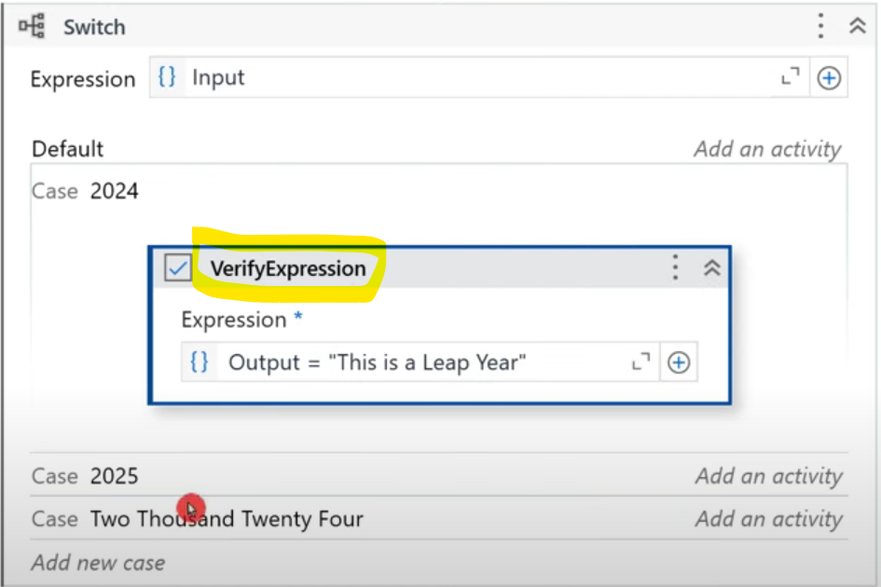

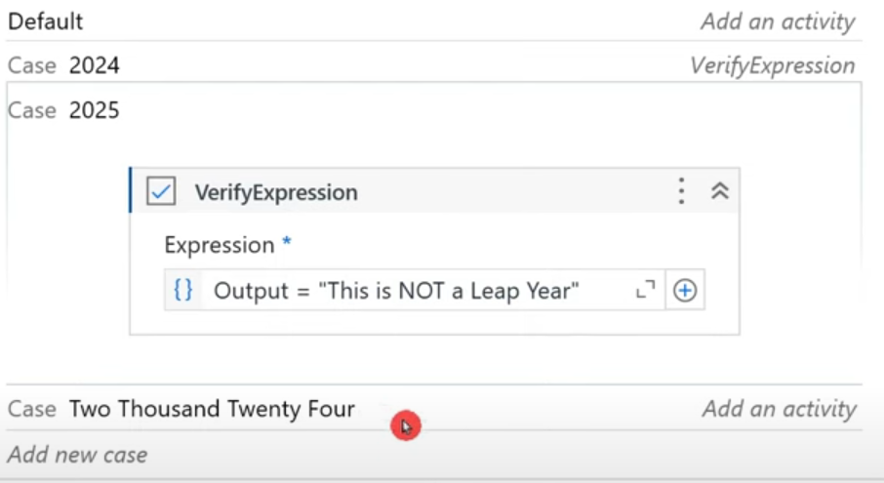

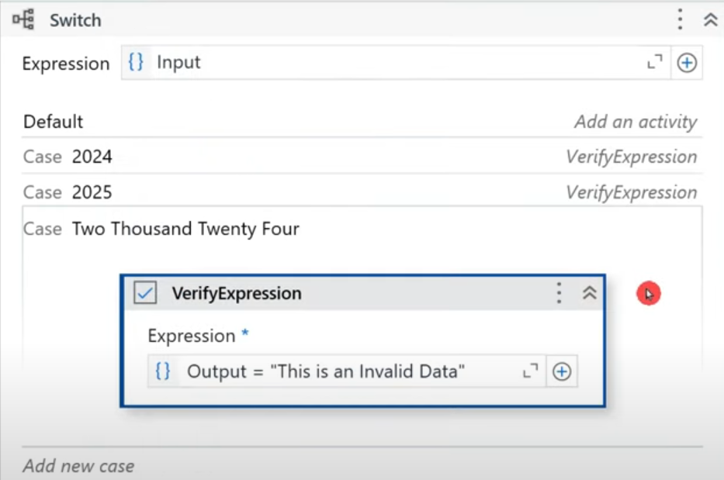

**The output coming from "WHEN" section is verified in the "THEN" section using verification activities inside Switch. This is to check if the code we built is giving proper expected output**.

When you run with input 2024, below is the output of test case. We should test all the inputs like this to test the code.

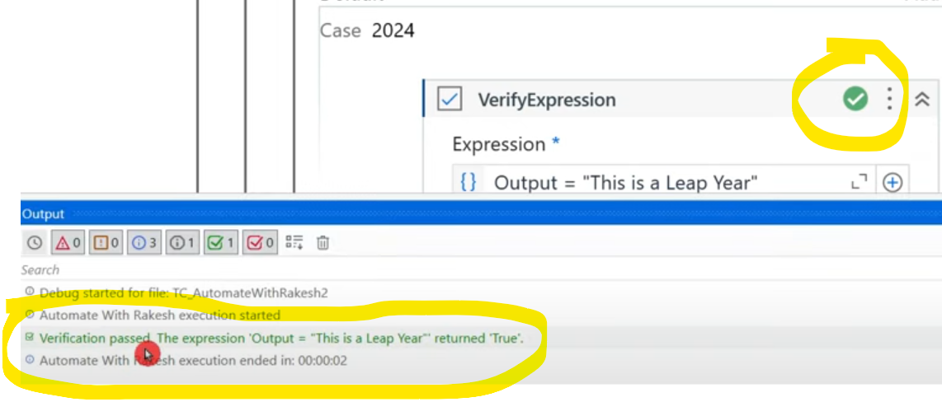

Even the 3rd input is verified like below with Cast exception.

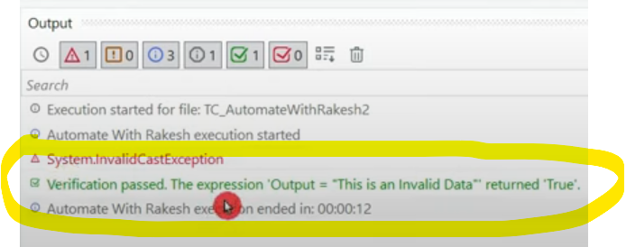

**NOTE: you need to understand clearly on what all variations can come and test all those in the test case.**

Let's test this way. Comment out "This is not a leap year" from ELSE section of IF activity & test the code by giving input 2025. Below is the verification from Switch activity of THEN section.

**When this happens, we need to go back to code & check the workflow & fix the issue. Then this updated code will reflect in test case and gives us results when run.**



